**NATIONAL UNIVERSITY OF COMPUTER AND EMERGING SCIENCES**

**PROGRAM: SOFTWARE ENGINEERING**



***WEB ENGINEERING LAB***

**LAB TASK 01**

**SUBMITTED BY:**

**Name: Ahmed Ali**

**Roll No: 22P-9318**

**Section: BS(SE)-6B**

**INSTRUCTOR NAME: Sir Zakria**

**A DEPARTMENT OF COMPUTER SCIENCE**

**CODE:**

<!DOCTYPE html>

<html>

<head>

<meta charset="utf-8"/>

<title>LAB TASK 01</title>

</head>

<body>

<ol>

<li>

CHAPTER 1

<ol type="A">

<li>Introduction</li>

<li>HTML</li>

</ol>

</li>

<li>

CHAPTER 2

<ol type="I">

<li>Tags</li>

<li>lists</li>

<ul type="square">

<li>This is the fist item od second item</li>

<ol>

<li>And this is the numbered subitem of first item</li>

</ol>

<li>This is seecond item of the second item</li>

<dl>

<dt>Title l</dt>

<dd>Definition 1</dd>

<dt>Title 2</dt>

<dd>Definition 2</dd>

<dd>Definition 3

<ul type="circle">

<li>Unordered list item 1</li>

<li>Unordered list item 2</li>

</ul>

</dd>

</dl>

</ul>

</ol>

</li>

</ol>

<ol start="3">

<li>

CHAPTER 3

</li>

</ol>

</body>

</html>

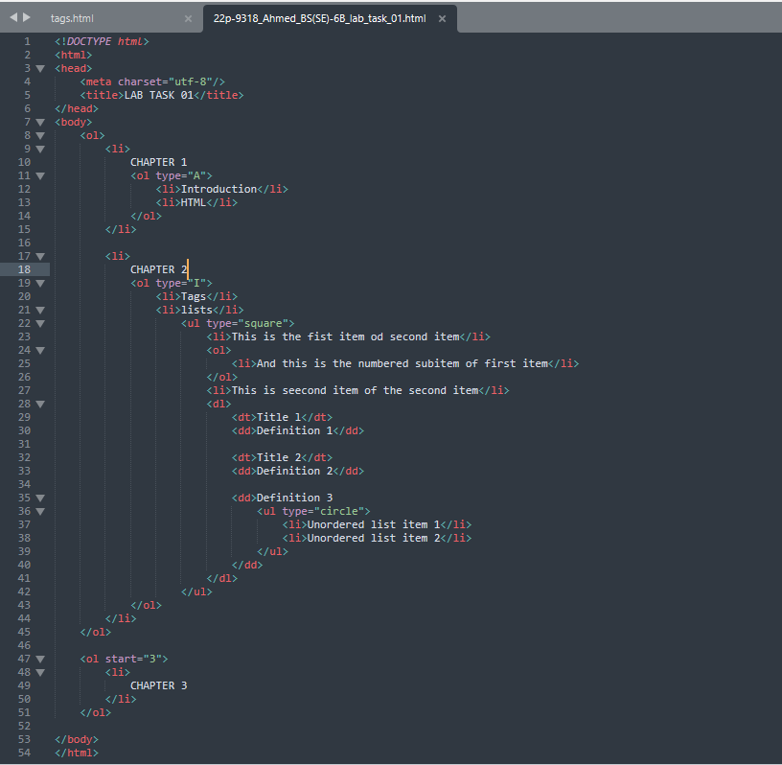

**SCREENSHOT OF OUTPUT BELOW:**

